School of Computer Science and Artificial Intelligence
Lab Assignment # 6

Name of Student : P.Vamshi krishna Enrollment No. : 2303A51452
Batch No. : 21

Task Description #1 (AI-Based Code Completion for Conditional Eligibility Check)
Task: Use an AI tool to generate eligibility logic. Prompt:
“Generate Python code to check voting eligibility based on age and citizenship.”

Prompt:-
Generate a Python program to check voting eligibility. Take age and citizenship as input from the user.
Use conditional statements to decide eligibility

Code:-
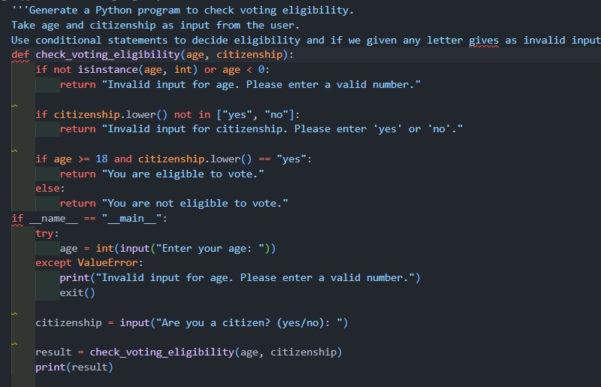

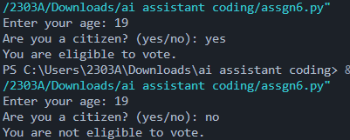
Justification:-
The user requested to complete the code in the middle given the prefix and suffix code snippets. The provided code snippet completes program as described, and the suffix contains additional tasks that are not part of program. The completion adheres to the user's request without altering or removing any existing code.

Task Description #2(AI-Based Code Completion for Loop-Based String Processing)
Task: Use an AI tool to process strings using loops. Prompt:
“Generate Python code to count vowels and consonants in a string using a loop.”
Prompt:-
Generate a Python program to count vowels and consonants in a string. Take the string as input from the user.
Use a loop to count and display the results. Code:
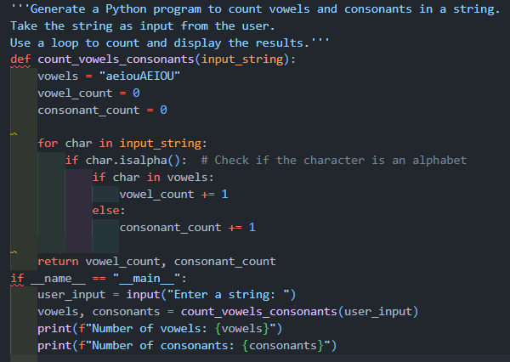

-

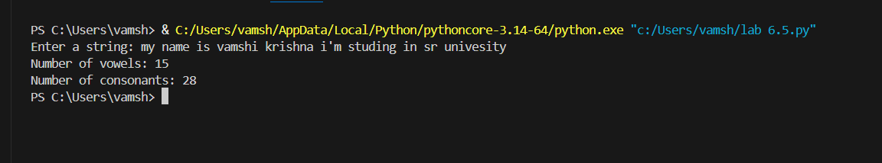

Justification:-
The function `count_vowels_consonants` correctly identifies vowels and consonants in a given string by iterating through each character and checking if it is an alphabetic character and whether it is a vowel or consonant.

Task Description #3 (AI-Assisted Code Completion Reflection Task)
Task: Use an AI tool to generate a complete program using classes, loops, and conditionals.

Prompt:-
Generate a Python library management system using classes, loops, and conditionals. Take book details and user choices as input dynamically.
Display menu options in a loop

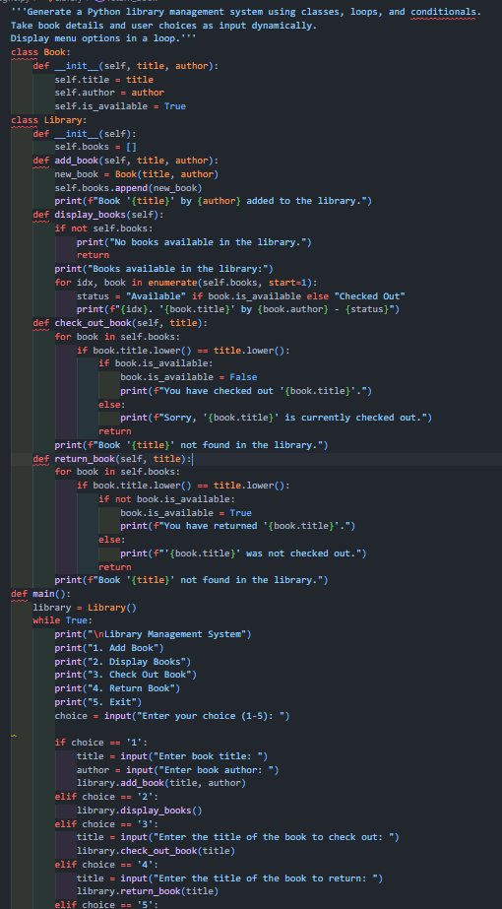

Code:

-

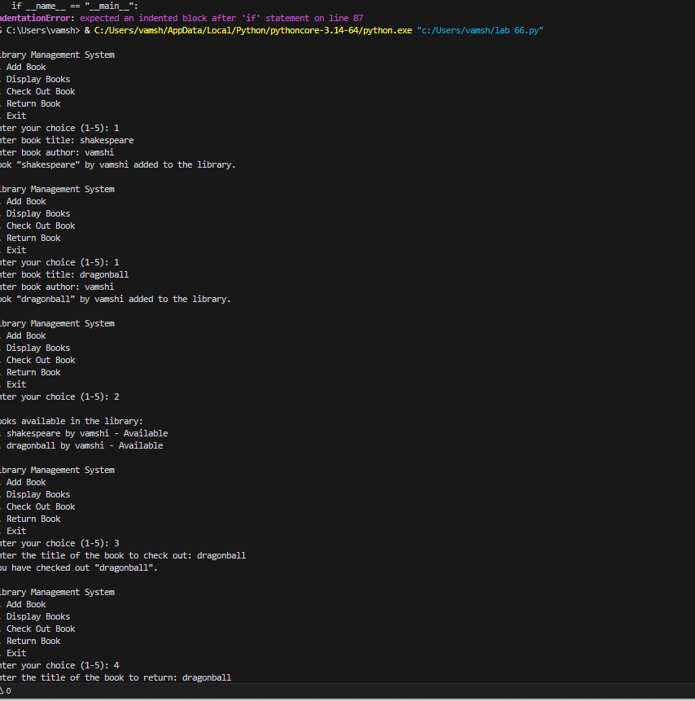

Justification:-
The above code implements a simple library management system using a class called
`Library`. The class has methods to add, remove, and display books. A loop is used to provide a menu-driven interface for the user to interact with the library system. Conditional statements handle user choices and validate inputs.

Task Description #4 (AI-Assisted Code Completion for Class- Based Attendance System)
Task: Use an AI tool to generate an attendance management class. Prompt: “Generate a Python class to mark and display student attendance using loops.”

Prompt:-
Generate a Python class for student attendance. Take student names as input from the user.
Use loops to mark and display attendance.

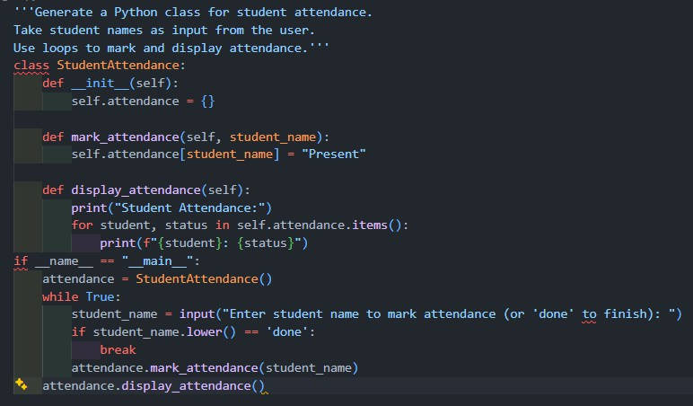

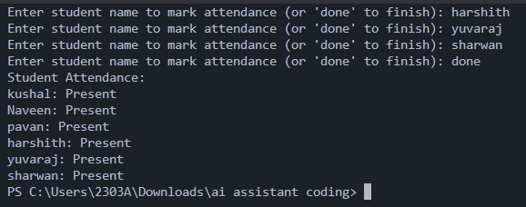

Justification:-
The code above implements an Attendance System using a class-based approach. It allows adding multiple students, marking their attendance, and displaying their attendance percentage. The program uses loops and conditional statements to interact with the user and manage the attendance records effectively.
Task Description #5 (AI-Based Code Completion for Conditional Menu Navigation)
Task: Use an AI tool to complete a navigation menu.
Prompt: “Generate a Python program using loops and conditionals to simulate an ATM menu.”

Prompt:-
Generate a Python ATM menu program using loops and conditionals. Take user choice and amount as input dynamically.
Continue showing the menu until the user exits

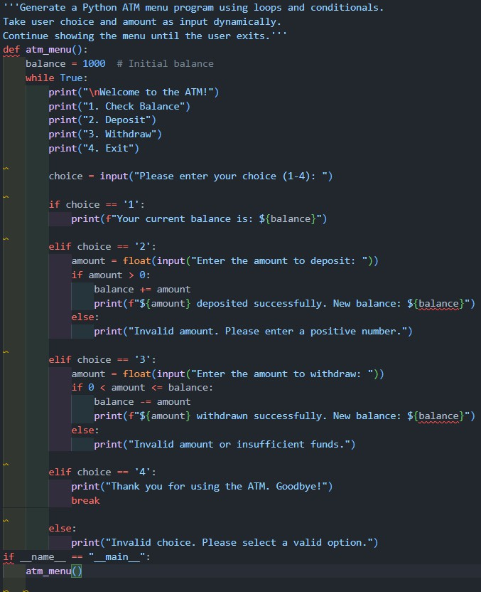

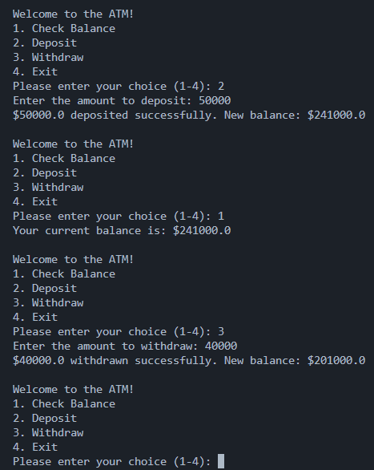

Justification:-
The user input is not one of the valid options (1-4), so the program informs them of the invalid choice and prompts them to try again. and continues the loop until a valid choice is made or the user decides to exit.

